Ques) What is probability.

Ans)

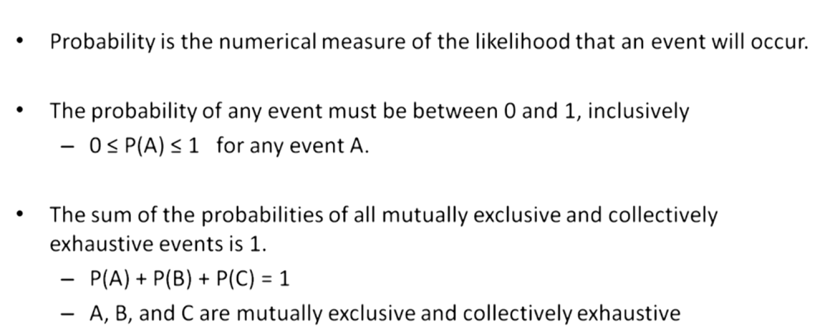

Ques) What is the methods of assigning probability.

Ans) Classical method(rules & laws).

Relative frequency(cumulated historical data).

Subjective probability(personal intuition or reasoning)

Ques) What is classical probability.

Ans) 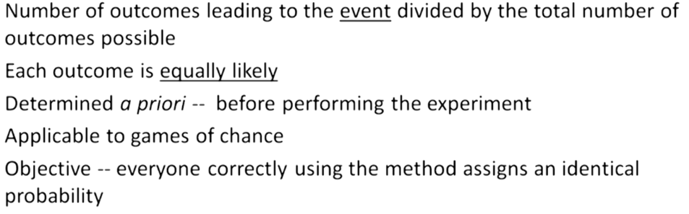

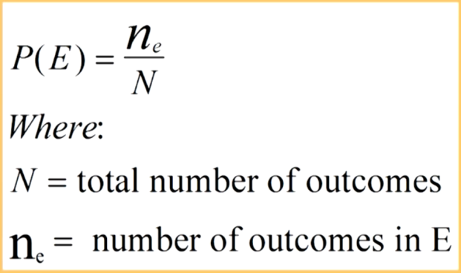

Ques) What is Relative Frequency Probability.

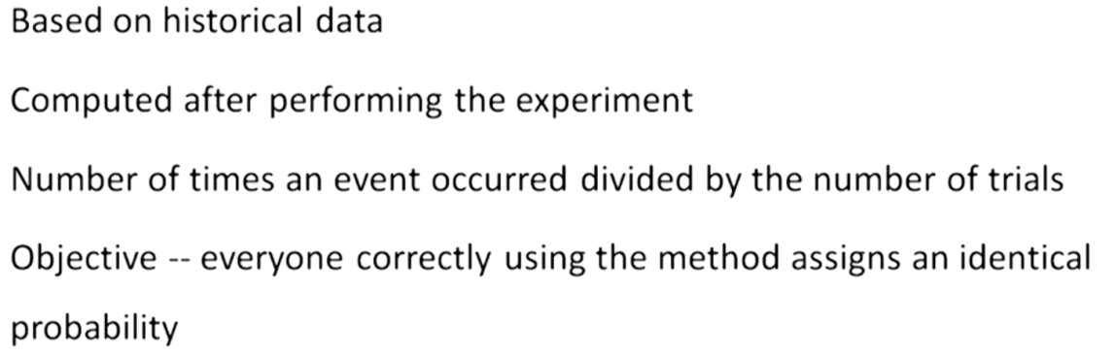

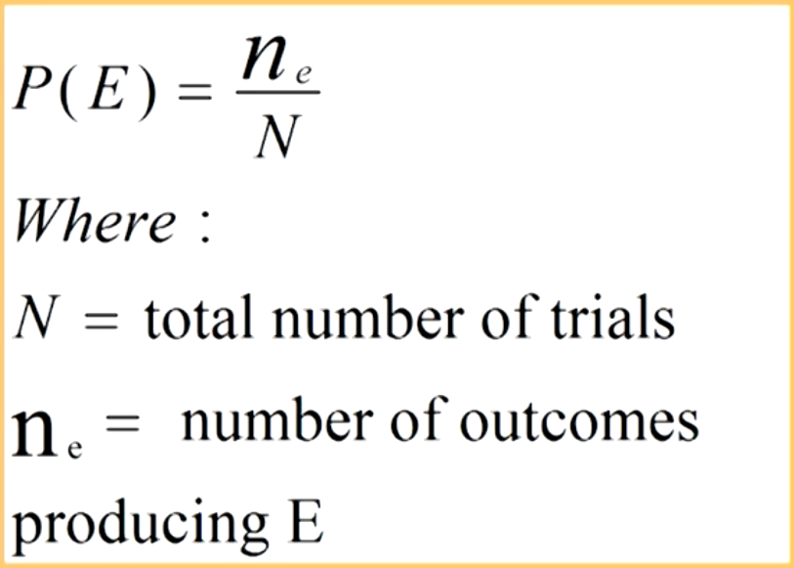

Ques) What is Subjective Probability.

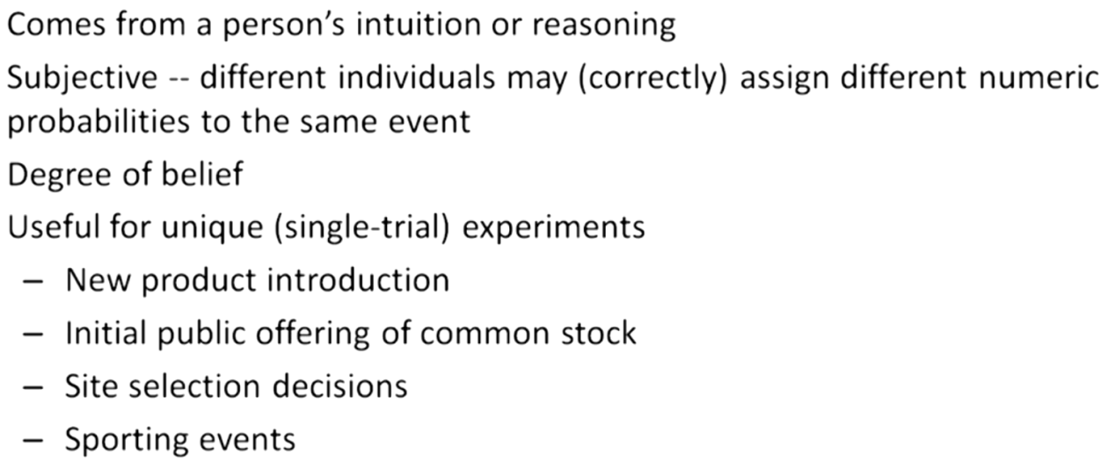

Ques) Explain what the following terms mean also give example.

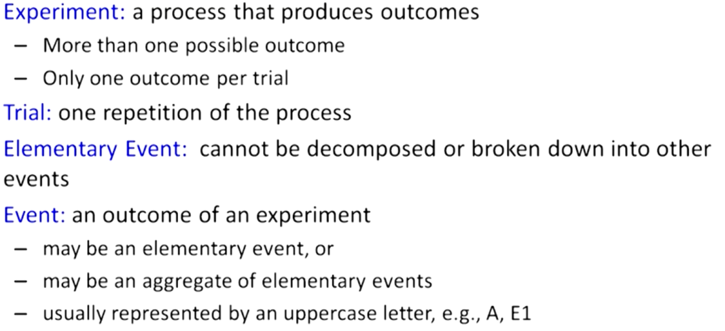

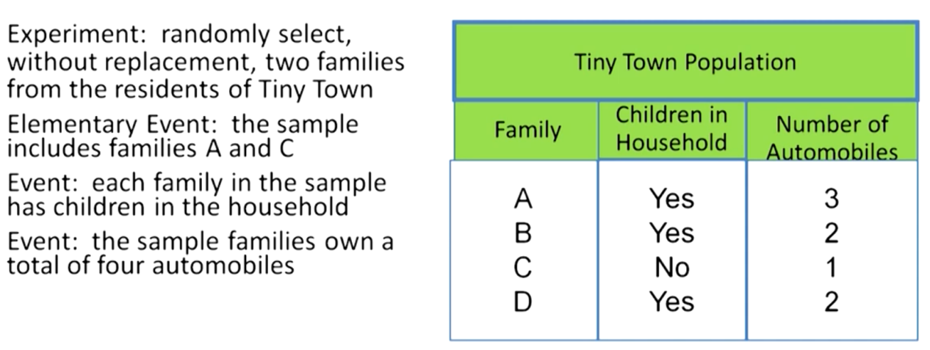

Ques) What is sample space and methods for describing sample space

Ans) Set of all elementary events i.e. All possible outcomes.

Different methods are.

1. Roster
2. Tree Diagram
3. Set Builder Notation
4. Venn Diagram.

Roster or Listing.

----->Through this method we make a listing of all possible outcomes pair for an event.

These possible sample space are written in normal format in english represented as pairs.

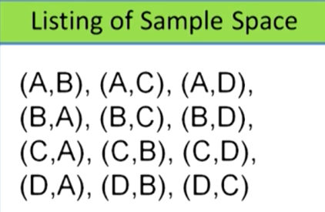

Tree Diagram.

----->In this method we make each class a different root nodes out of which different possibilities generate.

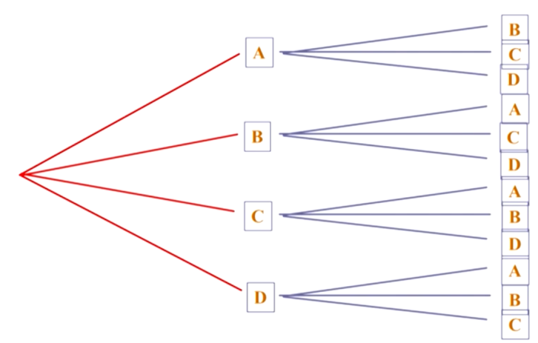

Set builder Notation.

----->It is the concise representation of large sample spaces. It is like the mathematical representation of the sample space.



Venn Diagram.

----->It is the dramatic notation to show sample space upon which different operations of union, intersection and various joints can be performed.

In the given sample space different circle/dots represent different sample space.

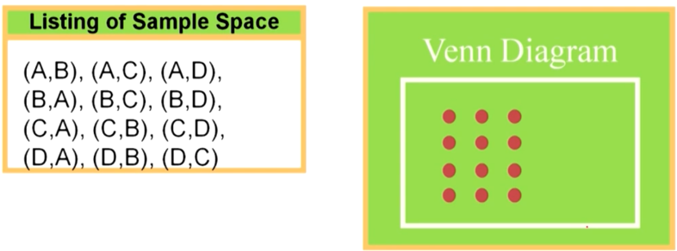

Ques) What are mutually exclusive events.

Ans) Events with no common outcomes.

Occurrence of one event prevent the occurrence of other event.

Eg. Event -- Tossing a coin.

Outcomes - Head/Tail.

Both cannot occur simultaneously.

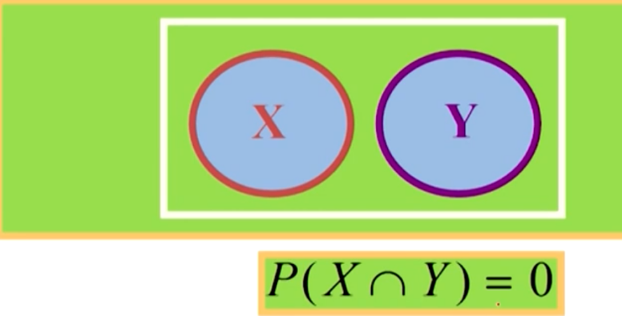

Ques) Independent Event.

Ans) Occurrence of one event does not influence the occurrence of other event.

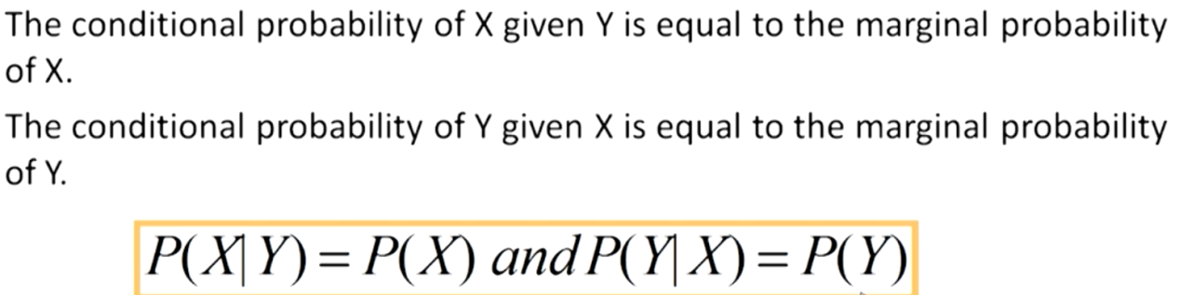

Ques) What is collectively Exhaustive Event.

Ans) Contains all elementary events/outcomes of a event.

Eg. Roll a die and all possible outcomes ie. 1,2,3,4,5 in a set is called collectively exhaustive events.

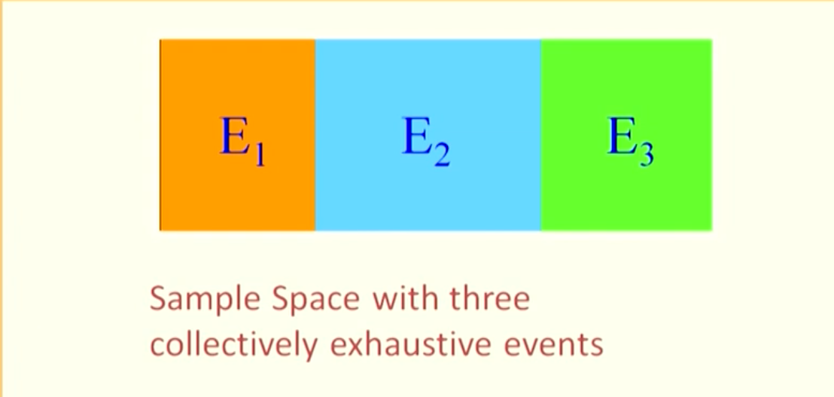

Ques) What is complementary Event.

Ans) All elementary-events/outcomes that are not in event ‘A’ are in its complementary event.

